Python OOP Regular Exam
Space Exploration

In the vast frontier of space exploration, skilled astronauts and well-equipped stations are essential for success.
The project simulates a space agency managing astronauts with different specializations and stations with unique functionalities.

Note: You cannot change the folder and file structure and their names!
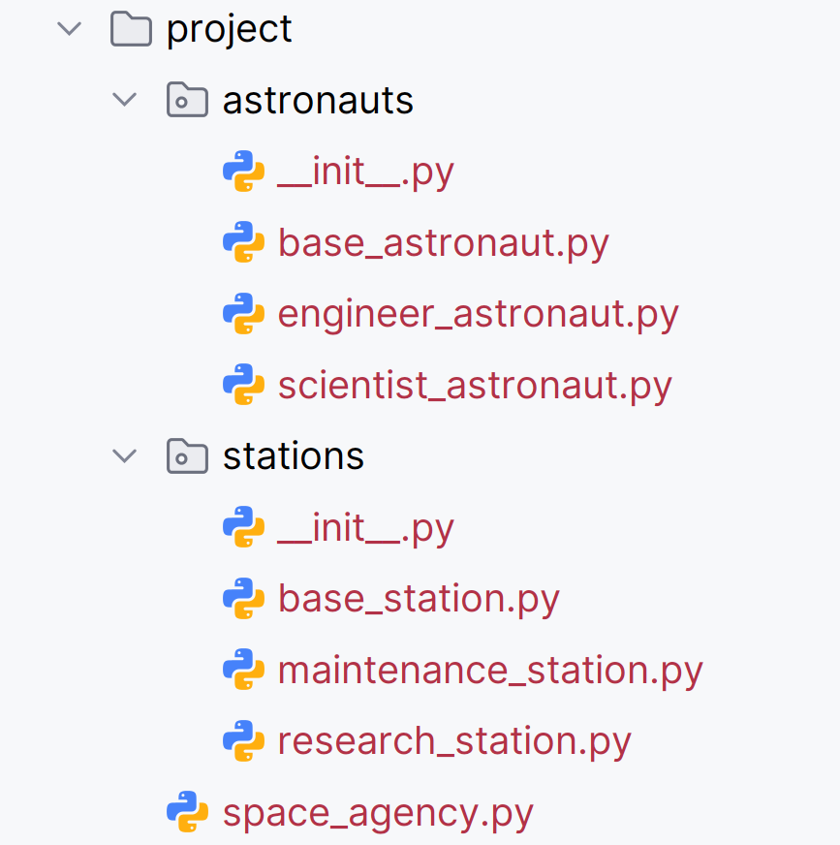
Judge Upload
For the first two problems, create a zip file with the project folder and upload it to the judge system.
For the last problem, create a zip file with the test folder and upload it to the judge system.
You do not need to include your venv, .idea, pycache, and __MACOSX (for Mac users) in the zip file, so you do not exceed the maximum allowed size of 16.00 KB.

Structure (Problem 1) and Functionality (Problem 2)
Your task is to implement all the classes' structure and functionality (properties, methods, inheritance, abstraction, etc.)
You are free to add additional attributes (instance attributes, class attributes, methods, dunder methods, etc.) to simplify your code and increase readability if it does not change the project's final result under its requirements so that the program works properly.

Class BaseAstronaut
In the base_astronaut.py file, the class BaseAstronaut should be implemented. It is a base class for all types of astronauts, and it should not be able to be instantiated.

Structure
The class should have the following attributes:
- id_number: str
  - The value represents the identity number (ID) of the astronaut.
  - The ID number can contain only digits, otherwise raise a ValueError with the message: "ID can contain only digits!"
- salary: float
  - Represents the salary of the astronaut.
  - If the salary is less than 0.0, raise a ValueError with the message: "Salary must be a positive number!"
- specialization: str
  - The value represents the specialization of the astronaut.
  - The specialization cannot be empty or contain white spaces only. If so, raise a ValueError with the message: "Specialization cannot be empty!"
- stamina: int
  - Represents the energy level of the astronaut.
  - Stamina must be between 0 and 100, both inclusive. If not, raise a ValueError with the message: "Stamina is out of range!"

Methods

__init__(id_number: str, salary: float, specialization: str, stamina: int)
- In the __init__ method, all the needed attributes must be set.

train()
- A method that increases astronauts' stamina for each training session.
- Remember that each astronaut type implements the method differently.

Class EngineerAstronaut
In the engineer_astronaut.py file, the class EngineerAstronaut should be implemented. An engineer astronaut is a type of base astronaut. Engineer astronauts have their specialization set to "EngineerAstronaut" and their stamina is initially set to 80 units.

Methods

__init__(id_number: str, salary: float)
- In the __init__ method, all the needed attributes must be set.

train()
- The method increases engineer astronauts' stamina by 5 units per session (per call). Make sure it does not exceed the maximum level of 100 units.

Class ScientistAstronaut
In the scientist_astronaut.py file, the class ScientistAstronaut should be implemented. A scientist astronaut is a type of base astronaut. Scientist astronauts have their specialization set to "ScientistAstronaut" and their stamina is initially set to 70 units.

Methods

__init__(id_number: str, salary: float)
- In the __init__ method, all the needed attributes must be set.

train()
- The method increases scientist astronauts' stamina by 3 units per session (per call). Make sure it does not exceed the maximum level of 100 units.

Class BaseStation
In the base_station.py file, the class BaseStation should be implemented. It is a base class for all types of stations, and it should not be able to be instantiated.

Structure
The class should have the following attributes:
- name: str
  - The value represents the name of the station.
  - The name can contain only letters, numbers, and hyphens. If it doesn't meet the criteria, raise a ValueError with the following message:
"Station names can contain only letters, numbers, and hyphens!"
- capacity: int
  - Represents the currently available capacity of the station.
  - The capacity must be greater than or equal to 0, otherwise raise a ValueError with the message: "A station cannot have a negative capacity!"
- astronauts: list
  - Initially set to an empty list.
  - It will store a collection of astronauts (objects) assigned to a station.

Methods

__init__(name: str, capacity: int)
- In the __init__ method, all the needed attributes must be set.

calculate_total_salaries()
- Calculates the value of total salaries for all assigned astronauts.
- Returns the calculated value, formatted to the second decimal place: "{total_salaries}"

status()
- Returns a string with information about the station in the format below.
  - The IDs of the assigned astronauts should be separated by a space and a hashtag (" #") and sorted alphabetically in ascending order.
    - If there are no astronauts, use the string "N/A" instead.
  - The value of the total salaries should be formatted to the second decimal place.
"Station name: {name}; Astronauts: {astronaut_ID₁ #astronaut_ID₂ #… #astronaut_ID_{n}/'N/A'}; Total salaries: {total_salaries}"

update_salaries(min_value: float)
- The method updates the salaries for certain astronauts assigned to the station whose salaries are less than or equal to the given min_value.
  - The method increases the salaries for the selected astronauts by a certain amount based on the station type.

Class ResearchStation
In the research_station.py file, the class ResearchStation should be implemented. A research station is a type of base station. A research station starts with an initial available capacity of 5 astronauts. The available capacity updates dynamically based on the number of assigned astronauts.

Methods

__init__(name: str)
- In the __init__ method, all the needed attributes must be set.

update_salaries(min_value: float)
- The method updates the salaries for scientist astronauts assigned to the research station whose salaries are less than or equal to the given min_value.
  - The method increases the salaries for the selected astronauts by 5000.0 USD.

Class MaintenanceStation
In the maintenance_station.py file, the class MaintenanceStation should be implemented. A maintenance station is a type of base station. A maintenance station starts with an initial available capacity of 3 astronauts. The available capacity updates dynamically based on the number of assigned astronauts.

Methods

__init__(name: str)
- In the __init__ method, all the needed attributes must be set.

update_salaries(min_value: float)
- The method updates the salaries for engineer astronauts assigned to the maintenance station whose salaries are less than or equal to the given min_value.
  - The method increases the salaries for the selected astronauts by 3000.0 USD.

Class SpaceAgency
In the space_agency.py file, the class SpaceAgency should be implemented. It will contain the project's functionality.

Structure
The class should have the following attributes:
- astronauts: list
  - Initially an empty list to store all astronaut objects available for assignments.
- stations: list
  - Initially an empty list to store all station objects owned by the agency.

Methods

__init__()
- In the __init__ method, all the needed attributes must be set.

add_astronaut(astronaut_type: str, astronaut_id_number: str, astronaut_salary: float)
The method adds (upon certain conditions) an astronaut of the given type and adds them to the agency's astronauts collection:
- First, check if the astronaut type is valid, and if not, raise a ValueError with the following message: "Invalid astronaut type!"
- Then, check if an astronaut with the same ID number is already added to the collection regardless of their type, do not duplicate IDs, and raise a ValueError with the following message: "{astronaut_id_number} has been already added!"
- If none of the above cases are reached, create and add the astronaut to the agency's astronauts collection. Return the following message:
"{astronaut_id_number} is successfully hired as {astronaut_type}."
- Valid types of astronauts are: "EngineerAstronaut" and "ScientistAstronaut"

add_station(station_type: str, station_name: str)
The method creates (upon certain conditions) a station of the given type and adds it to the agency's stations collection:
- First, check if the station type is valid, and if not, raise a ValueError with the following message: "Invalid station type!"
- Then, check if a station with the same name is already added to the list regardless of their type, do not duplicate names, and raise a ValueError with the following message:
"{station_name} has been already added!"
- If none of the above cases are reached, create and add the station to the agency's stations collection. Return the following message:
"{station_name} is successfully added as a {station_type}."
- Valid types of stations are: "ResearchStation" and "MaintenanceStation"

assign_astronaut(station_name: str, astronaut_type: str)
The method performs an assignment upon certain conditions. The agency assigns a specific astronaut of the given type to a station with the given name if all pre-defined conditions are met:
- First, check if such a station exists:
  - Validate a station's existence with the given name in the collection of the agency's stations.
  - If no station is found, the method raises a ValueError with the following message:
"Station {station_name} does not exist!"
- Then, check if an astronaut of the given type exists:
  - Validate the existence of an astronaut of the given type in the agency's collection of astronauts. Take the first occurrence in insertion order if such exists.
  - If no astronaut is found, the method raises a ValueError with the following message:
"No available astronauts of the type!"
If both objects exist, proceed with the assigning attempt:
- First, check if the station has an available capacity to accept the assignment of the astronaut:
  - If the station has no capacity, the assignment is impossible.
  - Return the message: "This station has no available capacity."
- Then, the agency assigns the astronaut to the station. A series of actions are required:
  - The astronaut is removed from the agency's astronauts collection.
  - The astronaut is added to the station's collection of assigned astronauts.
  - The station's available capacity is decreased accordingly.
  - Return the following message:
"{astronaut_id_number} was assigned to {station_name}."

train_astronauts(station: BaseStation, sessions_number: int)
The method performs training sessions for all astronauts assigned to the given station object (always a valid one). The number of training sessions is passed as an argument "sessions_number" and will always be a valid integer in the range [0-3] inclusive.
- The method performs as many training sessions as the sessions_number argument dictates.
- Each type of astronaut gains different levels of stamina per session.
  - Remember that training should not increase stamina above its maximum (100 units).
  - Hint: Use the train() method for each astronaut.
- Return the following message:
"{station_name} astronauts have {total_stamina} total stamina after {sessions_number} training session/s."
- The total_stamina represents the sum of all assigned to the station astronauts' stamina levels after the training sessions.

retire_astronaut(station: BaseStation, astronaut_id_number: str)
The method retires (removes) an astronaut object with the given ID number if it exists and is assigned to the given station (always a valid object) upon the following conditions:
- First, check if such an astronaut exists in the station's collection of assigned astronauts. If it does not exist or the object exists but the stamina level is at its maximum (100 units), cancel the process and return a message:
"The retirement process was canceled."
- If the astronaut object exists and the stamina level is below maximum, remove it from the assigned astronauts' collection, update the station's available capacity, and return the following message:
"Retired astronaut {astronaut_id_number}."

agency_update(min_value: float)
The method updates the salaries for certain astronauts assigned to stations depending on the min_value argument. Afterward, it should return detailed information about the agency's stations including the updated data.
- First, update all astronaut salaries that are less than or equal to the min_value, following the specific stations' rules.
  - Hint: Utilize the update_salaries() method to apply the updates properly for each station.
  - You are not supposed to update the salaries for available astronauts.
- Then, return information about stations and their assigned astronauts after updates.
  - Sort them by the number of assigned astronauts in descending order.
  - If there is more than one station with the same number of assigned astronauts, sort them by the station's name ascending.
  - Sort the astronaut IDs in the station's collections alphabetically in ascending order.
    - If there are no astronauts, use the string "N/A" instead. See the Examples.
  - The total_salaries value should be formatted to the second decimal place.
  - Hint: You can use the station's status() method.
- The returned up-to-date information should follow the format of the example below (each station's info is on a new line):
"*Space Agency Up-to-Date Report*
Total number of available astronauts: {available_astronauts_count}
**Stations count: {stations_total_count}; Total available capacity: {total_available_capacity}**
Station name: {name₁}; Astronauts: {astronaut_ID₁ #astronaut_ID₂ #… #astronaut_ID_{n}/'N/A'}; Total salaries: {total_salaries}
Station name: {name₂}; Astronauts: {astronaut_ID₁ #astronaut_ID₂ #… #astronaut_ID_{n}/'N/A'}; Total salaries: {total_salaries}
...
Station name: {name_{n}}; Astronauts: {astronaut_ID₁ #astronaut_ID₂ #… #astronaut_ID_{n}/'N/A'}; Total salaries: {total_salaries}"

Examples
Test Code
# Create an instance of the Space Agency Manager
manager = SpaceAgency()

# Add astronauts (engineers & scientists)
print(manager.add_astronaut("EngineerAstronaut", "02345", 780_000.0))
print(manager.add_astronaut("EngineerAstronaut", "1234", 500_000.0))
print(manager.add_astronaut("EngineerAstronaut", "789123", 800_000.0))
print(manager.add_astronaut("EngineerAstronaut", "45678999", 702_000.0))
print(manager.add_astronaut("ScientistAstronaut", "321654", 401_000.0))
print(manager.add_astronaut("ScientistAstronaut", "6543211", 490_000.0))
print(manager.add_astronaut("ScientistAstronaut", "334654", 600_000.0))
print(manager.add_astronaut("ScientistAstronaut", "034654", 395_000.0))
print()

# Add stations
print(manager.add_station("MaintenanceStation", "Lunar-Base"))
print(manager.add_station("ResearchStation", "ISS-3"))
print(manager.add_station("ResearchStation", "Mars-Habitat"))
print()

# Assign astronauts to stations
print(manager.assign_astronaut("Lunar-Base", "EngineerAstronaut"))
print(manager.assign_astronaut("Lunar-Base", "EngineerAstronaut"))
print(manager.assign_astronaut("Lunar-Base", "ScientistAstronaut"))
print(manager.assign_astronaut("ISS-3", "ScientistAstronaut"))
print(manager.assign_astronaut("ISS-3", "ScientistAstronaut"))
print(manager.assign_astronaut("ISS-3", "EngineerAstronaut"))
print(manager.assign_astronaut("ISS-3", "EngineerAstronaut"))
print()

# Conduct training sessions
print(manager.train_astronauts(manager.stations[0], 0))
print(manager.train_astronauts(manager.stations[0], 1))
print(manager.train_astronauts(manager.stations[0], 2))
print(manager.train_astronauts(manager.stations[0], 3))
print(manager.train_astronauts(manager.stations[0], 3))
print(manager.train_astronauts(manager.stations[1], 0))
print(manager.train_astronauts(manager.stations[2], 1))
print()

# Retire an astronaut
print(manager.retire_astronaut(manager.stations[2], "334654"))
print(manager.retire_astronaut(manager.stations[0], "02345"))
print(manager.stations[0].astronauts[0].id_number, manager.stations[0].astronauts[0].stamina)
print(manager.retire_astronaut(manager.stations[0], "111111"))
print(manager.retire_astronaut(manager.stations[1], "45678999"))
print()

# Perform an agency-wide update
print(manager.agency_update(500_000.0))
print()

# Check astronaut salaries after the update
print(manager.stations[0].astronauts[0].salary)
print(manager.stations[0].astronauts[1].salary)
print(manager.stations[0].astronauts[2].salary)
print()
print(manager.stations[1].astronauts[0].salary)
print(manager.stations[1].astronauts[1].salary)
print(manager.stations[1].astronauts[2].salary)
print()
print(manager.astronauts[0].salary)
Output
02345 is successfully hired as EngineerAstronaut.
1234 is successfully hired as EngineerAstronaut.
789123 is successfully hired as EngineerAstronaut.
45678999 is successfully hired as EngineerAstronaut.
321654 is successfully hired as ScientistAstronaut.
6543211 is successfully hired as ScientistAstronaut.
334654 is successfully hired as ScientistAstronaut.
034654 is successfully hired as ScientistAstronaut.

Lunar-Base is successfully added as a MaintenanceStation.
ISS-3 is successfully added as a ResearchStation.
Mars-Habitat is successfully added as a ResearchStation.

02345 was assigned to Lunar-Base.
1234 was assigned to Lunar-Base.
321654 was assigned to Lunar-Base.
6543211 was assigned to ISS-3.
334654 was assigned to ISS-3.
789123 was assigned to ISS-3.
45678999 was assigned to ISS-3.

Lunar-Base astronauts have 230 total stamina after 0 training session/s.
Lunar-Base astronauts have 243 total stamina after 1 training session/s.
Lunar-Base astronauts have 269 total stamina after 2 training session/s.
Lunar-Base astronauts have 288 total stamina after 3 training session/s.
Lunar-Base astronauts have 297 total stamina after 3 training session/s.
ISS-3 astronauts have 300 total stamina after 0 training session/s.
Mars-Habitat astronauts have 0 total stamina after 1 training session/s.

The retirement process was canceled.
The retirement process was canceled.
02345 100
The retirement process was canceled.
Retired astronaut 45678999.

*Space Agency Up-to-Date Report*
Total number of available astronauts: 1
**Stations count: 3; Total available capacity: 7**
Station name: ISS-3; Astronauts: 334654 #6543211 #789123; Total salaries: 1895000.00
Station name: Lunar-Base; Astronauts: 02345 #1234 #321654; Total salaries: 1684000.00
Station name: Mars-Habitat; Astronauts: N/A; Total salaries: 0.00

780000.0
503000.0
401000.0

495000.0
600000.0
800000.0

395000.0

Problem 3: Unit Testing (100 points)
You will be provided with another skeleton for this problem. Open the new skeleton as a new project and write tests for the StarSystem class. The class will have some methods, fields, and one constructor, all of them working properly. You are NOT ALLOWED to change anything in the class code. Cover the whole class with unit tests to make sure that the class is working as intended. Submit only the test folder.

